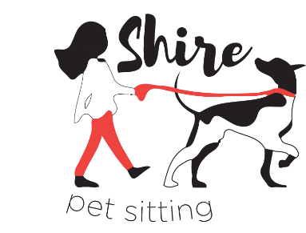
+ How to Leave a Review

Shire Pet Sitting encourages you to call, text or email your sitter with any concerns at any time. However, online reviews can help us determine how to better our services and/or how to maintain levels of satisfaction. They can also promote the business and get our name out there!
If you can, please take some time to write an online review. There are three options: Google, Facebook or both! If you have the time to write both, they can be the same review. All that matters is each site has a review on it!
Down below, I explain how to complete these reviews with pictures. Of course, you can call or text if you have any questions. Thank you so much!

- Google Review
  - Go to www.google.com
  - Search “Shire Pet Sitting” or “Shire Pet Sitting, Cheshire, CT”
  - Click on “Write a Review” in the box on the right (as illustrated below) and follow the directions!

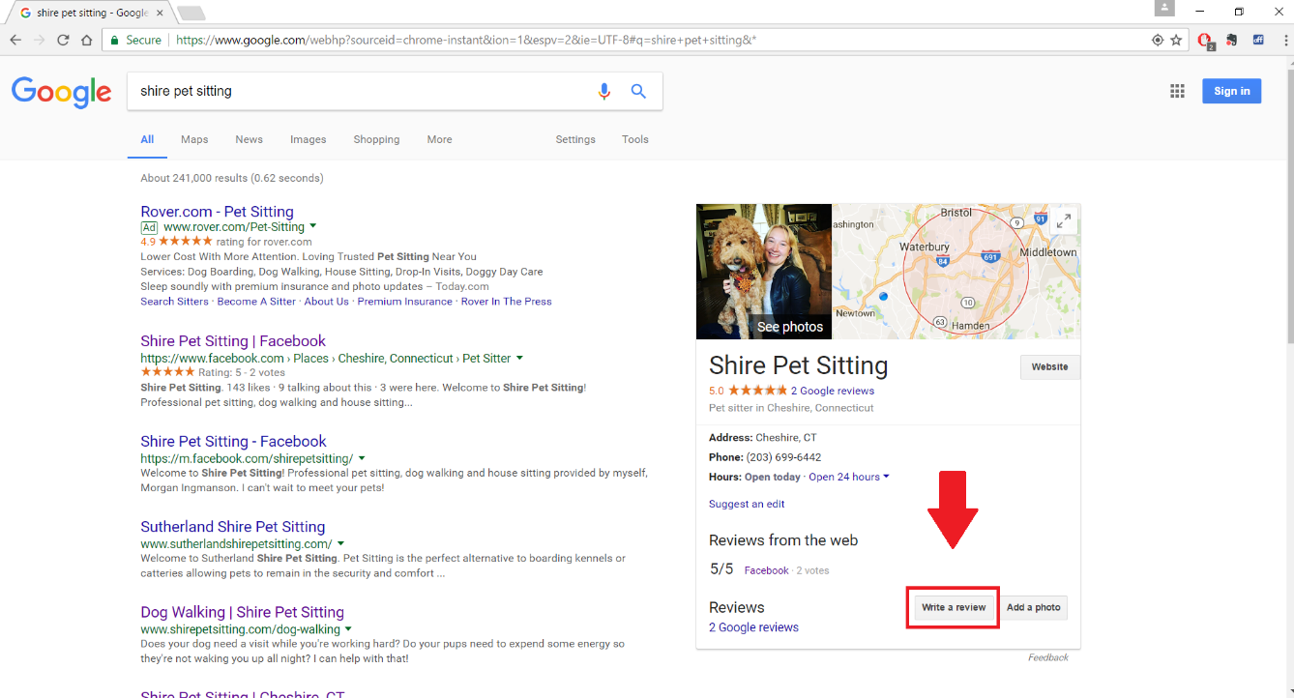

- Facebook Review
  - Go to www.facebook.com/shirepetsitting
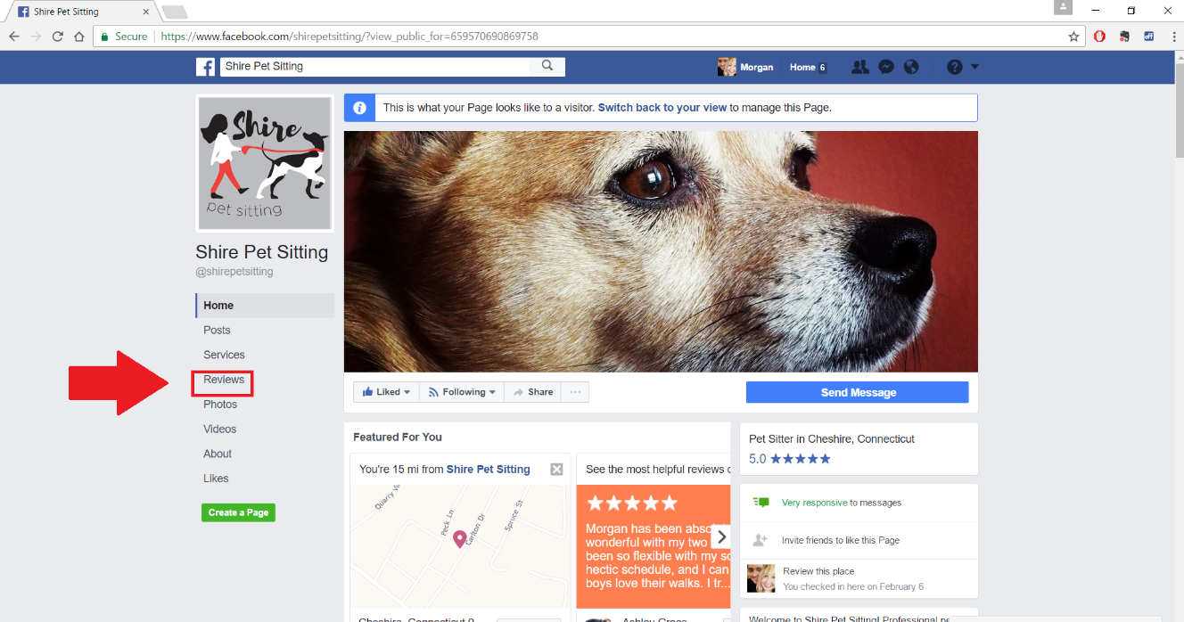
  - Click on “Reviews”

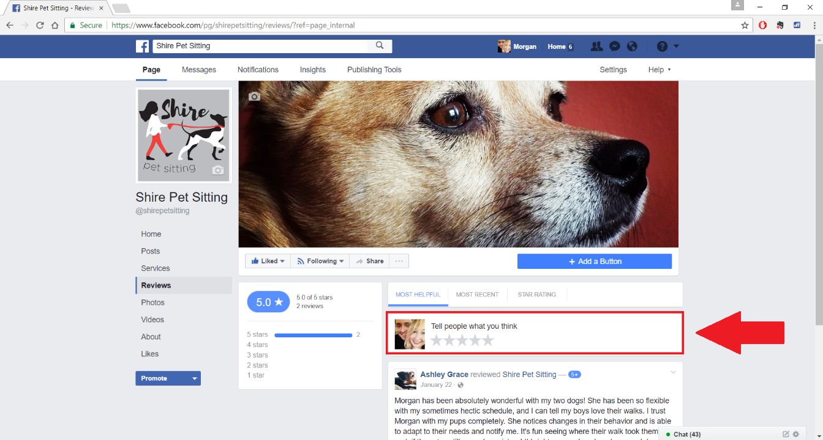
  - Leave a review! Then “like” and “follow” the page if you haven’t already!

