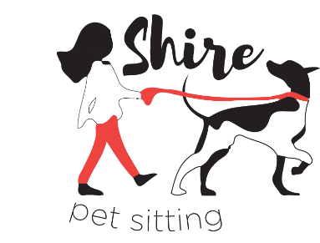
Contact Sheet

Pet Sitter: Morgan Ingmanson

Phone Number: 203-699-6442

Email: shirepetsitting@gmail.com

At Shire Pet Sitting, we aim to be a community, not just a business. You and your pets are a part of our family. Keep in touch by “liking” our Facebook page, “following” us on Instagram and visiting the website. Chances are, your pets will make a photo appearance on our pages!

Website: www.shirepetsitting.com

Facebook Page: www.facebook.com/shirepetsitting

Instagram: @shirepetsitting

Shire Pet Sitting is only as strong as its clients are happy. If you have any comments, questions or concerns, please do not hesitate to contact me at any time. Welcome to the family!

